Internet of things

Project Title: Automated Home Lighting System Using Smart Phone

Submitted By:

Suhaas. C

Mohith. GV

ABSTRACT

The world is converging towards wireless as a communication channel and at the same time facing energy and environmental problems. The solution is by mingling the information technology (IT) and power. The proposed smart light control system outclasses the previous systems because it integrates the low power communication protocol Particle Photon with the LED lights.

The system lets the user control home lights remotely over the internet according to his preference using a simple smartphone application. The smartphone app uses the IFTTT protocol to communicate between devices. The initial experimental results show that it saves remarkable effort as compared to conventional systems. This efficiency increases even two fold by considering the advantage of remotely monitoring and controlling the lights through the centralized point. Thus the proposed system is the cost effective and efficient system satisfying the needs of the modern users.

REQUIREMENTS

The following is a list of materials which were required for the project

Hardware Requirements

* Particle photon
* Bread Board
* Usb
* Power Source
* A Led Bulb
* An Android or IOS Device

Software Requirements

* Particle App
* IFTTT App
* IFTTT DO Button App
* An Particle Account
* An IFTTT Account

SYSTEM DESCRIPTION

Hardware Description

* 1. Particle photon

Particle P0 Wi-Fi module  
Broadcom BCM43362 Wi-Fi chip  
STM32F205 120Mhz ARM Cortex M3  
1MB flash  
128KB RAM   
802.11b/g/n  
Soft AP setup  
FCC/CE/IC certified  
18 on board I/O pins

* 1. Bread Board

A **breadboard** is a construction base for [prototyping](https://en.wikipedia.org/wiki/Prototype) of [electronics](https://en.wikipedia.org/wiki/Electronic_circuit). Originally it was literally a bread board, a polished piece of wood used for slicing bread. In the 1970s the **solderless breadboard** (AKA plug board, a terminal array board) became available and nowadays the term "breadboard" is commonly used to refer to these. "Breadboard" is also a synonym for "[prototype](https://en.wikipedia.org/wiki/Prototype)".

1.3 Usb

**USB** (**Universal Serial Bus**) is the most popular connection used to connect a computer to devices such as digital cameras, printers, scanners, and external hard drives. **USB** is a cross-platform technology that is supported by most of the major operating systems.

Here we utilize the USB to provide power supply to the particle photon

1.4 Power Source

A Source of power required to power up the particle photon. It can be a charger, a laptop or a power bank.

1.5 A Led Bulb

A **light-emitting diode** (**LED**) is a two-lead semiconductor light source. It is a p–n junction diode, which emits light when activated. When a suitable voltage is applied to the leads, electrons are able to recombine with electron holes within the device, releasing energy in the form of photons.

1.6 An Android or IOS Device

A Smart Device used to support the software that is necessary to simulate the applications that are required to connect to the particle photon and send signals to it.

Software Description

2.1 Particle App

The particle application is used to send signals or messages to the particle photon.

2.2 IFTTT App

**IFTTT** is a free web-based service that allows users to create chains of simple conditional statements, called "recipes", which are triggered based on changes to other web services such as Gmail, Facebook, Instagram, and Pinterest. **IFTTT** is an abbreviation of "If This Then That".

**IFTTT** lets you connect the **apps** and devices you use every day, such as Amazon Alexa, Facebook, Twitter, Fitbit, Slack, and more.

2.3 IFTTT DO Button App

**DO Button** is your shortcut to the things you **do** most often. Save time and control your world by connecting **DO Button** to Philips Hue, LIFX, Google Drive, Nest Thermostat, WeMo, Twitter, Evernote, Slack, and hundreds of **apps** and devices you use every day.

2.4 A Particle Account

The particle account is used to Write and flash code to your **Particle** devices.

2.5 An IFTTT Account

The IFTTT account is used to select channels that we are interested in and allows us to create recipes that are used to perform specific tasks

BLOCK DIAGRAM

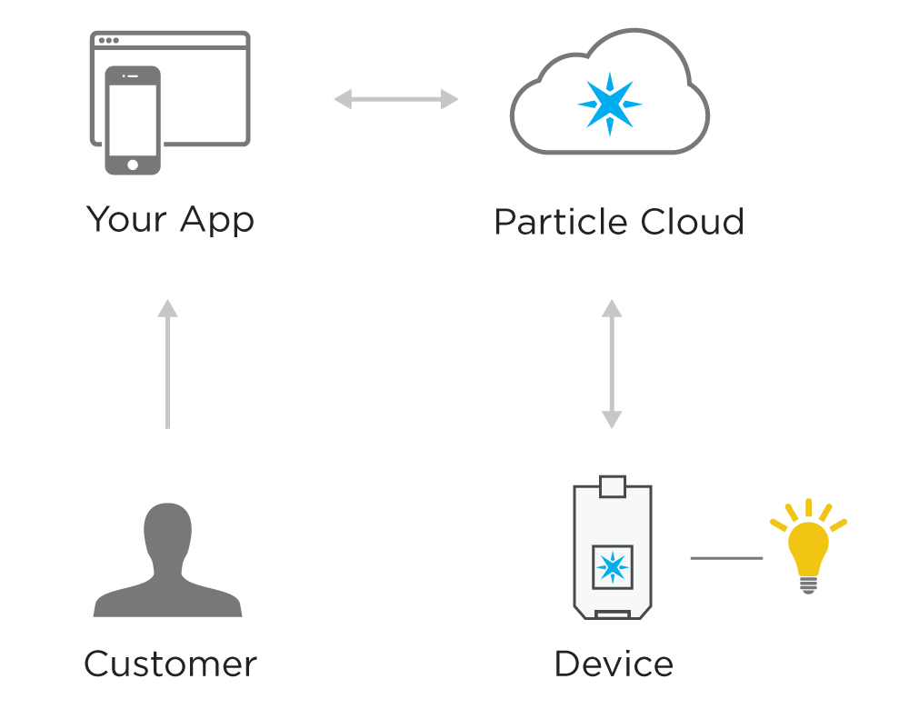

CIRCUIT DIAGRAM

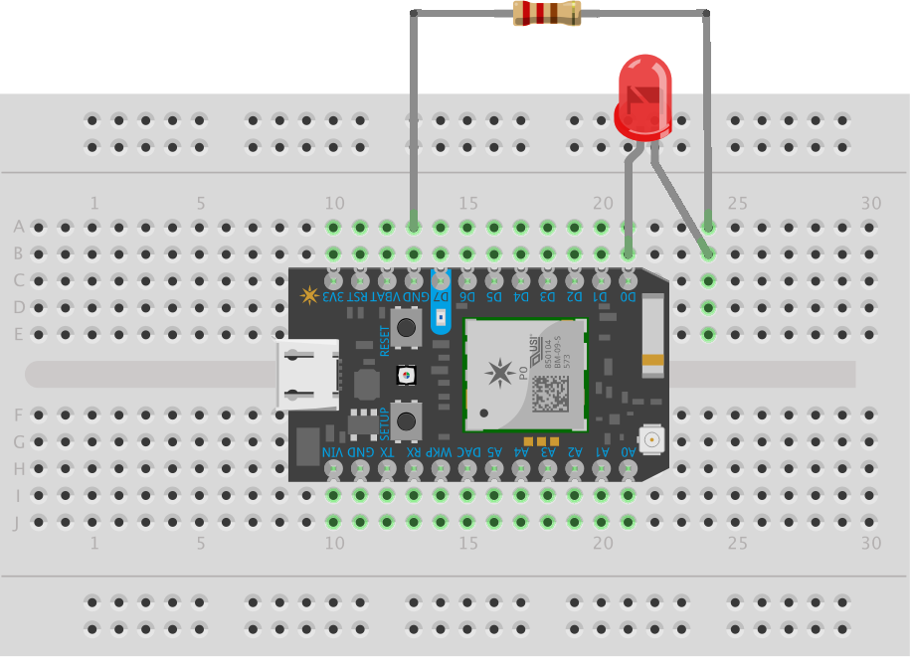

CODE

int led1 = D0;

int led2 = D7;

void setup() {

pinMode(led1, OUTPUT);

pinMode(led2, OUTPUT);

}

void loop() {

// To switch on the LED, first we'll turn it on...

digitalWrite(led1, HIGH);

digitalWrite(led2, HIGH);

// We'll leave it on

delay(1000);

digitalWrite(led1, LOW);

digitalWrite(led2, LOW);

delay(0000);

}

CONCLUSION

Our vision of establishing a smarter home lighting system was achieved in the making of this project. This Project has helped me understand Internet of Things (IOT) in detail. It has helped me overcome the challenges of coding and has made me more versatile. It has also brought us to be in touch with the happening technology and has made me more curious in the field of IOT.

Some of the main challenges faced during the course of the project :

* Understanding the working of the do button app and integrating it with the function written over the cloud.
* Coding the function that switches the led on and off as per need.